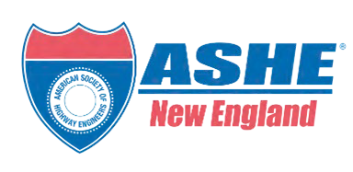
GROUNDBREAKING LAUNCH
NEW ENGLAND SECTION

NETWORK, CELEBRATE, AND BECOME A CHARTER MEMBER


Revere Hotel
5:00 - 8:00 PM
ABOUT OUR EVENT!
EVENT LAUNCH HIGHLIGHTS

What we require from you is simple: please register and click on "I COMMIT" to join as a member. Your commitment is essential for our official recognition as a chartered Section.
Don't miss this monumental event to shape the future of the ASHE New England Section and make your mark in the engineering world. We look forward to seeing you!






ASHE NE SECTION EXECUTIVE BOARD OF DIRECTORS:
President
Carrie Lavalle
Deputy Administrator & Chief Engineer - MassDOT
Vice President
Joe Pavao
Associate VP & Business Unit Manager - Dewberry
Treasurer
Sarah Tanner
MBTA Acting Director of Professional Service Procurement MBTA
Secretary
Andrew Clarke
Senior Transportation Designer - Stantec
For event inquiries, contact Kristine Gorman
at Kristine.Gorman@Parsons.com
Be immortalized as a founding member who helped


launch this prestigious organization

Connect with top industry professionals and peers
Elevate the event with $100 sponsorship opportunities


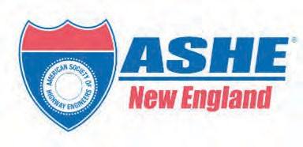
COST OF ANNUAL MEMBERSHIP
Public (Federal, State, Municipality), Students & Retirees:
New Members $45/ Membership Renewal $45
Private Sector:
New Members $85/ Membership Renewal $65

ASHE New England

Section Directors

COST OF ANNUAL SPONSORSHIP


GOLD: $2500 SILVER: $1500 BRONZE: $1000
Director Marketing/Programs


Kristine Gorman
Vice President - Parsons Transportation Group
Director Membership/Sponsorship


Joseph Strafaci
Regional Manager - French & Parrello Associates

