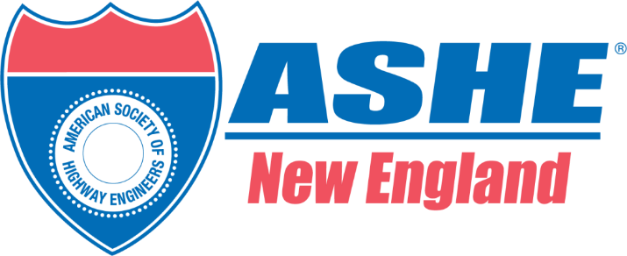
ASHE New England Chapter Inaugural Mentoring Program
Mentor Application

The Young Member & Student Outreach Committee of ASHE New England is seeking participants for the inaugural 2026 Mentoring Program. All are invited to apply to participate in this program with no previous mentoring experience required. Mentors will be paired with mentees based on:
- Career/employment background
- Leadership experience
- Mentee’s stated professional and mentoring program goals.
Additionally, a matching meeting will be held during our first meeting. It is the intent of that meeting for mentors and mentees to make acquaintances. Following this meeting, a survey will be distributed in which the Mentee and Mentor will rank their three strongest connections. The committee will take that into consideration with the above criteria and make matches accordingly.

Further details about the program are provided below.

Applications are due June 26th, 2026. Please email this application and other required documents to Maria Firan (maria.firan@jacobs.com) and Sarah Goldstein (sgoldstein@hntb.com) with Joseph Strafaci (Joseph.Strafaci@tylin.com) cc’d.

Eligibility and Requirements
To be eligible to participate in the Mentoring Program as a Mentor, applicants must:
- Have at least 5 years of professional experience in in transportation, planning, public policy, construction, or related fields and have the desire to assist others to grow personally and professionally.
- Be an industry professional with demonstrated experience in their chosen field with the ability to inspire mentees to learn, grow, seek new possibilities, and take calculated risks, acting as allies, catalysts, and coaches.
- Be able to commit 3 hours per month for six months between July and December 2026. It is expected that the Mentors will meet with their mentee’s for at least one hour per month, as well as participate in the ASHE NE Monthly Mentoring group event (further information provided below), as well as do at least a half hour of preparation for each of these meetings.
- For the monthly group events it is anticipated that there will be five total with two in-person after work on Wednesday. The anticipated schedule is as follows:
Month | Format | Agenda
July 22nd | In-Person | Introduction & Matching
August 19th | Virtual | Hear from a Mentor
September 23rd | Virtual | Professional Development
October 28th | Virtual | Hear from a Mentor
December 2nd | In-Person | Graduation/Keynote Speaker
- Please note that as a part of this program we are looking to have two Mentors speak to the group regarding their career, experience, and participate in a Q&A. It is the intent to select the Mentors with the highest interest from mentees during the matching meeting should the Mentor agree to this additional level of participation.
To apply for the program, please submit the following:
- Completed Application Form
- Current Resume/CV
- Headshot in JPEG or PNG format.

Application
Name
Employer and/or Organization
Position
Address
Email
Phone Number
- Please provide a bio describing your work history, leadership, and any mentoring experience in 250 words.

- Why would you like to be a Mentor?

- Describe what to you makes the perfect Mentee?

- Please note your preferred method of communication with a mentee.

- If selected for the program, would you be open to participating/leading one of the Hear from the Mentor Sessions?
Yes / No
- ASHE NE understands the commitment and would like to celebrate your participation. Do we have permission to Post your photo and Biography to our website?
Yes / No

